**Listview with Searchview**

1. **Add Task Description:**

Creating a Static News Data Application with the using of Listview and Searchview for filter Data in News in Android. (Using Java)

1. **Attach Screenshot of Output.**

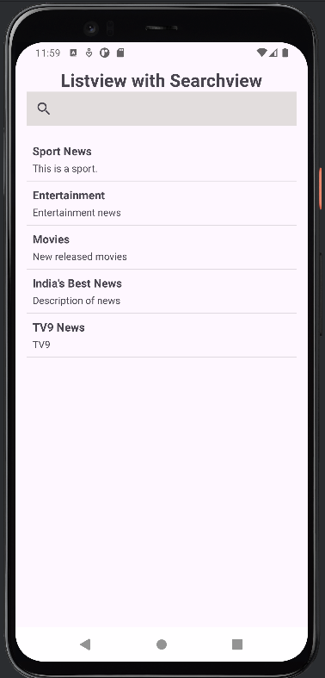 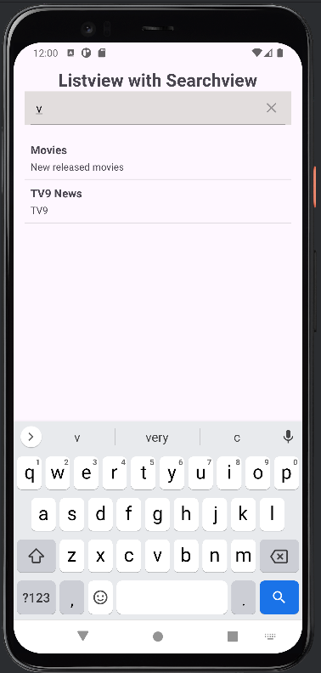

1. **Describe Widget/Algorithm Used In Task**

**Listview :** Listview display a data in vertical list of scroll-able views

**Search view :** Search view provides user interface to search data/item/query and filter the data.

**Data Model :** To represent each news item.